SIMATS ENGINEERING (SAVEETHA SCHOOL OF ENGINEERING)
Department of Computer Science and Engineering

ASSESSMENT TOOL 2– Case Study (2 QUESTIONS)

Course Code: | ITA05 | Course Title: | COMPUTER VISION
CO Assessed: | CO3 – Precision (BL4) | Assessment: | Assessment Tool 1 – Case Study
Weightage: | 40% of CIA | Total Marks: | 20 (2 Questions × 10Marks)
CO1 Statement: | Analyze and extract image features using detection and matching techniques for effective image representation and comparison..(BL4)
Student Name: | Hemapriya.J | Reg. No.: | 192521431
Section / Batch: | 2025/hostel/slot c | Date:
2
Code of Conduct
I Hemapriya.J(192521431) certify that this submission is my original work and that I have adhered to the guidelines specified for this assessment. I understand that any violation of academic integrity rules will result in disciplinary action.

Signature of the Student:Hemapriya.J
Instructions
- This test contains 2 questions, each carrying 10 marks. Total: 20 Marks.
- No negative marking. Unanswered questions carry zero marks.
- No calculators or electronic devices permitted.
- Duration: 60 minutes.

Section / Topic | Focus | Q Nos | Marks
Feature Detection and Matching | Preprocessing, Edge Detection, Harris Corner Detection, Hough Transform, SIFT | 1 | 10
Feature Detection and Matching | PCA, Image Representation, Feature Matching, Image Processing Applications | 2 | 10
GRAND TOTAL: |  | 20 Marks

Annexure A –Case Study

A remote sensing application is used to align satellite images of the same geographical region captured at different times for monitoring environmental changes. The system initially relies on edge detection to identify matching regions between the images; however, due to differences in illumination, image orientation, and background details, the matching process becomes unreliable and produces inaccurate alignment results. The development team decides to replace the edge-based approach with Harris Corner Detection to identify stable and distinctive feature points. Analyze the limitations of edge detection in this application and explain how Harris Corner Detection improves feature localization, matching accuracy, and robustness for image registration under varying imaging conditions.

- An autonomous surveillance system continuously captures high-resolution color images to detect vehicles and pedestrians in real time. Processing the original color images directly increases computational complexity and slows down feature extraction, making it difficult to achieve the required processing speed. To improve system performance, the engineers consider converting the images into grayscale or binary representations before applying feature detection algorithms. Analyze the impact of different image representations on computational efficiency, edge detection, and feature extraction performance, and justify the most appropriate image representation for achieving accurate and reliable object detection in real-time computer vision applications.

Rubrics for Calculation

Criteria | Weig htage | Level 4 – Exemplary | Level 3 – Proficient | Level 2 – Developing | Level 1 – Beginning | Marks
Understanding of Case | 25 | Thorough understanding; clearly identifies all key issues | Good understandin g with most issues identified | Basic understanding  ; some issues missed | Poor understanding; problem not identified correctly
Application of Concepts | 25 | Effectively applies relevant concepts to analyze the case deeply | Applies appropriate concepts with minor gaps | Limited application of concepts | Fails to apply relevant concepts
Analysis | 20 | In-depth analysis with strong reasoning and insights | Good analysis with logical reasoning | Basic analysis with limited depth | Weak or no analysis; lacks reasoning
Solution Design | 20 | Innovative, feasible solutions with strong justification | Logical solutions with adequate justification | Basic solutions with weak justification | Incorrect or no solution provided
Clarity | 10 | Clear, well-structured, and easy to understand | Organized and understanda ble presentation | Limited clarity and structure | Poor clarity; difficult to understand

Faculty In-charge
Signature:
Date:

Q1. Remote Sensing Image Alignment using Harris Corner Detection

Understanding of Case
The given problem involves aligning satellite images of the same geographical region captured at different times. The key challenges include:
  - Illumination variation due to different lighting conditions (time, weather)
  - Orientation differences caused by satellite angle or rotation
  - Background complexity such as vegetation, water, and urban structures
  - Unreliable feature matching using edge detection
The goal is to improve image registration accuracy by replacing edge-based feature detection with a more robust technique.
Introduction
Remote sensing systems capture satellite images of the same geographical region at different times to monitor environmental changes. Before comparing these images, they must be accurately aligned or registered.
Initially, the system uses edge detection to identify corresponding regions. However, changes in illumination, orientation, shadows, and background details make edge-based matching unreliable. Therefore, Harris Corner Detection is introduced to identify stable and distinctive feature points.

Limitations of Edge Detection
Edge detection identifies boundaries where there is a sudden change in intensity. Although edges are useful for identifying object boundaries, they have several limitations in satellite image registration.
- Edges are continuous features, not unique points, making correspondence difficult.
- Illumination changes can change the strength and location of detected edges.
- Image rotation or orientation changes can produce different edge patterns.
- Background details such as roads, buildings, vegetation, and shadows may generate unwanted edges.
- Noise can produce false edges.
- Long or parallel edges may result in ambiguous matching.
- Edge detection does not provide precise feature locations suitable for transformation estimation.

Application of Concepts Edge Detection Concept
  - Detects intensity gradients (e.g., Sobel, Canny)
  - Identifies boundaries but not unique feature points

Harris Corner Detection Concept
  - Detects corner points (interest points) where intensity changes in multiple directions
  - Uses structure tensor (second-moment matrix)
  - Corner response function:

Analysis
Limitations of Edge Detection

Sensitivity to Illumination
  - Edge strength depends on intensity → varies with lighting
  - Leads to missing or false edges

Poor Feature Uniqueness
  - Edges are continuous lines
  - Difficult to identify exact matching points

Rotation Sensitivity
  - Edge orientation changes with rotation
  - Matching becomes inconsistent

Noise and Background Clutter

  - Natural scenes produce excessive edges
  - Reduces matching accuracy

Weak Localization
  - Edges do not provide precise point coordinates
  - Results in inaccurate alignment
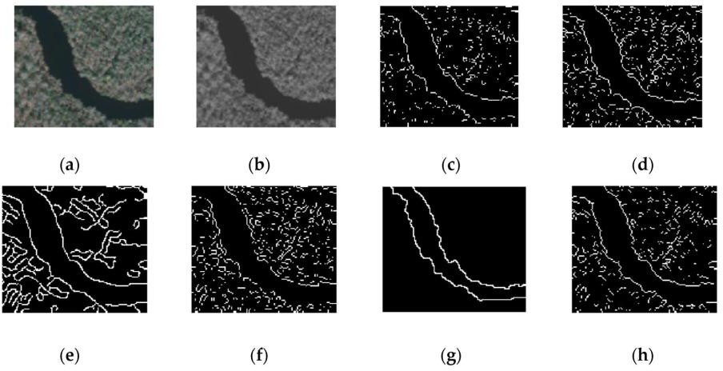
Fig1: Edge detection produces excessive and irrelevant edges, making matching unreliable.

Performance Improvement
- Accurate Feature Localization
  - Detects distinct corner points
  - Provides precise (x, y) coordinates

High Distinctiveness
  - Corners (e.g., building edges, intersections) are unique
  - Improves matching reliability

Robust to Illumination Changes
  - Based on relative intensity variations
  - Less affected by brightness differences

Rotation Invariance
  - Corners remain stable under rotation
  - Ensures consistent matching

Noise Resistance
  - Uses window-based analysis → smoothens noise effects

Solution Design Harris Corner Detection
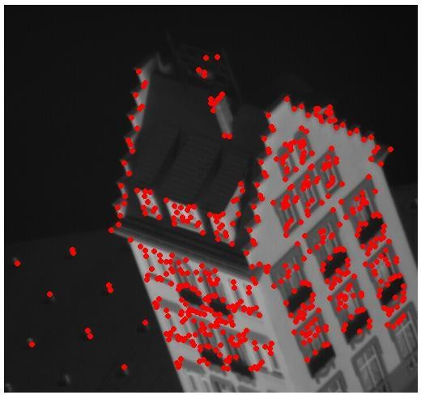

Fig 2: Harris Corner Detection identifies distinct and stable feature points for accurate matching.

Preprocessing
  - Convert images to grayscale
  - Apply smoothing (Gaussian filter)

Feature Detection
  - Apply Harris Corner Detection to both images

Feature Matching
  - Match corner points using distance metrics (e.g., SSD, NCC)

Transformation Estimation
  - Use algorithms like RANSAC to remove outliers

Image Registration
  - Align images using affine or homography transformation

Justification of Solution
- Provides stable and repeatable features
- Reduces false matches
- Works effectively under varying environmental conditions
- Improves alignment accuracy significantly

Conclusion
Edge detection fails in remote sensing applications due to its sensitivity to illumination, lack of distinctiveness, and poor localization. Harris Corner Detection overcomes these limitations by identifying stable, unique, and well-localized feature points. This results in improved matching accuracy and robust image alignment even under varying imaging conditions, making it a more suitable approach for satellite image registration.

Q2. Choosing the Right Image Representation for Real-Time Surveillance

Understanding the Scenario

An autonomous surveillance system captures high-resolution color images to detect vehicles and pedestrians in real time. However, processing full RGB images increases computational load, slowing down feature extraction and affecting real-time performance. Therefore, alternative representations like grayscale and binary images are considered.

Different Ways to Represent Images
- Color (RGB): Contains three channels (Red, Green, Blue)
- Grayscale: Single intensity channel (brightness only)
- Binary: Pixels are either 0 or 1 (black & white)

Comparison of Image Representations
- Color Images (RGB)
  - High computational cost (3 channels)
  - Slower processing speed
  - Contains rich information but often redundant for edge detection
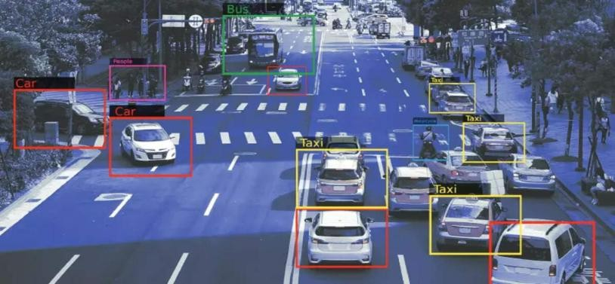
Fig 1: RGB image contains detailed color information but increases processing complexity.

Advantages
  - Preserves complete color information.
  - Useful when object color is important.
  - Can distinguish objects having similar shapes but different colors.
  - Provides rich information for advanced object recognition.

Limitations
  - Requires more memory.
  - Feature extraction is computationally expensive.
  - Edge detection has to process more data.
  - Processing three channels can reduce real-time performance.

Grayscale Images
A grayscale image represents each pixel using a single intensity value ranging from dark to bright. A common conversion can be represented as:
Gray=0.299R+0.587G+0.114B
  - Reduces data size (single channel)
  - Faster processing
  - Preserves structure, edges, and shapes
  - Suitable for most feature detection algorithms

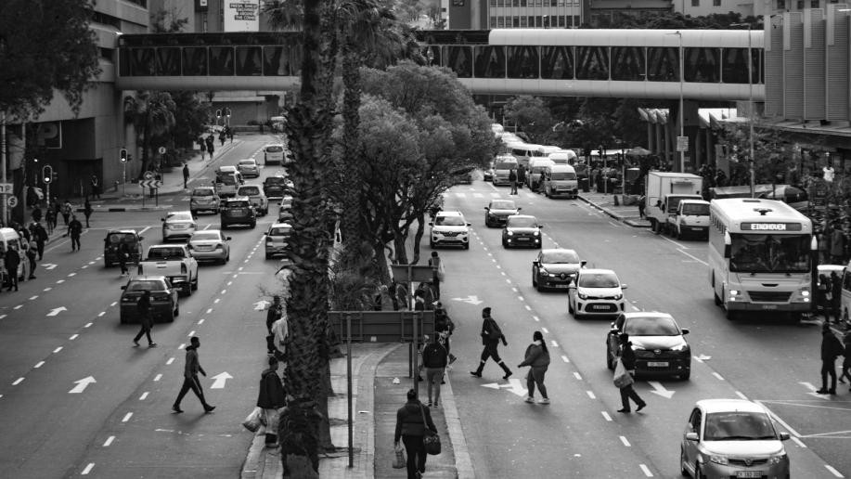
Fig2: Grayscale image retains important structural details while reducing computation.

Binary Images
A binary image contains only two pixel values, usually 0 and 1, representing black and white. Binary conversion generally requires a threshold:
B(x,y)= 1,0,I(x,y)>T
I(x,y)≤T
  - Very low computational cost
  - Fastest processing
  - Loses most details (depends on thresholding)
  - Sensitive to noise and lighting
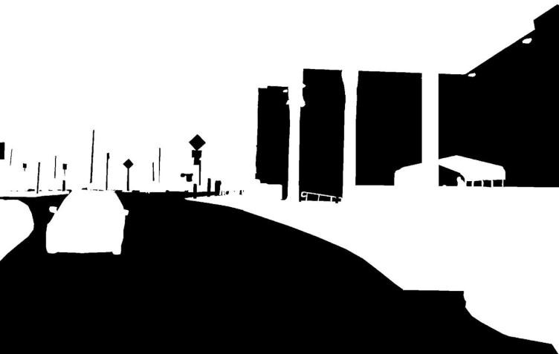
Fig 3: Binary image loses important features and may lead to incorrect detection.

Effect on Edge Detection
Image representation has a major effect on edge detection.

RGB Images
Edges can be detected from changes in multiple color channels, but processing is more computationally expensive.

Grayscale Images
Grayscale provides a strong intensity representation. Algorithms such as Sobel, Prewitt, and Canny can efficiently identify object boundaries.

Binary Images
Edges are already represented as transitions between black and white regions. Although processing is fast, thresholding may create false boundaries or remove genuine boundaries.

Effect on Feature Extraction
Feature extraction identifies important information such as:
  - Corners
  - Edges
  - Keypoints
  - Shape
  - Texture
  - Object boundaries

Color
  - Provides the maximum information but requires greater computational resources.

Grayscale
  - Provides sufficient structural information for many feature detectors while requiring considerably less computation.

Binary
Provides basic shape and boundary information but may lose important features because of thresholding.

Impact on Performance

Representation | Speed | Edge Detection | Feature Quality
Color | Slow | Moderate | High but redundant
Grayscale | Fast | Strong | High (balanced)
Binary | Very Fast | Weak | Poor

Best Approach for Real-Time Detection Grayscale Representation is the most suitable Reasons:
  - Reduces computational complexity significantly
  - Maintains important edge and shape information
  - Works efficiently with feature detectors (Harris, SIFT, ORB)
  - Provides a balance between accuracy and speed

Conclusion
Processing color images directly is computationally expensive and slows down real-time systems, while binary images lose critical information required for accurate detection. Grayscale images provide an

optimal balance by reducing computation while preserving essential structural features. Therefore, grayscale representation is the most effective choice for accurate and reliable real-time object detection in surveillance systems.

